Latest Numbers - Nov 2007

These are the images of the latest number reports for Meter News 85 – including those that nearly made it!
.

FSC907 Series

Source: DA (MN 85)
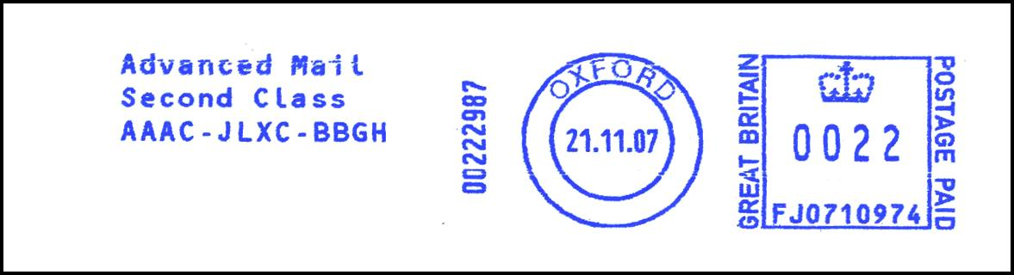
FJ0710 Series

Source: RG (MN 85)

FM2116 Series

Source: AN (MN 85)

FU8002 Series

Source: AN (MN 85)

FU9001 Series

Source: AN (MN 85)

T402 Series

Source: AN (MN 85)

N1161 Series

Source: DA (MN 85)


N1208 Dead Series Update

Source: AN

N1240 Series

Source: AN (MN 85)

N1371 Series

Source: PM (MN 85)

N1381 Series

Source: DA (MN 85)

PBP84 Series

Source: PM (MN 85)

PB01 Series

Source: AN (MN 85)


PB129 Dead Series Update

Source: AN

PB130 Series

Source: AN (MN 85)

PB311 Series

Source: AN (MN 85)

PB482 Series

Large jump

Source: AN (MN 85)

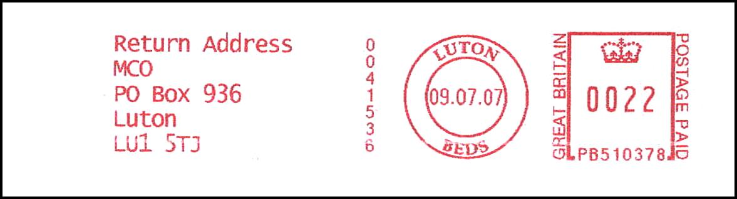
PB510 Dead Series Update

Source: PM

PB523 Series

Source: DA (MN 85)

PB763 Series

Source: RG (MN 85)

PB832 Series

Source: AN (MN 85)
. . . and those that almost made it:


FJ0710 Series

Source: RG

FU8002 Series

Source: RG

N1161 Series

Source: AN
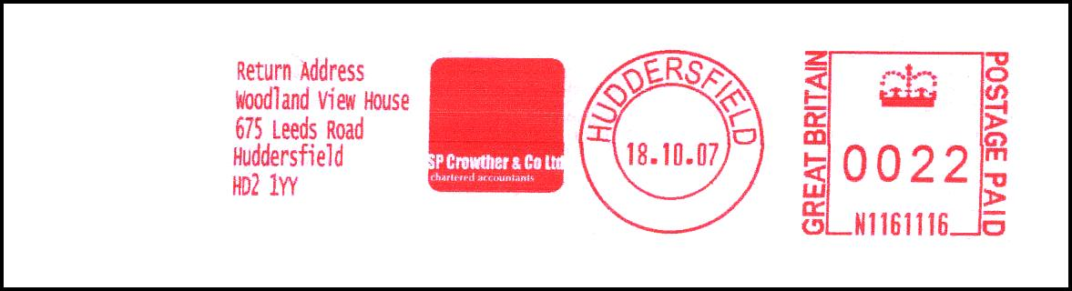
N1161 Series

Source: RG

N1161 Series

Source: AN


N1208 Dead Series Update

Source: PM

N1381 Series

Source: AN

PB01 Series

First Day? (Item No. 4)

Source: AN

PB130 Series

Source: AN

PB482 Series

Source: AN

PB831 Series

Source: AN

PB831 Series

Source: RG

PB831 Series

Source: AN

PB832 Series

Source: AN

PB832 Series

Source: AN
PB832 Series

PB832361 - 07.11.07 CHATHAM / KENT (user unknown)
No illustration available

Source: PW

